LEADERSHIP AND INFLUENCE

This page intentionally left blank.
Lesson 1. Course Introduction

This page intentionally left blank.

COURSE OVERVIEW
Visual 1.1

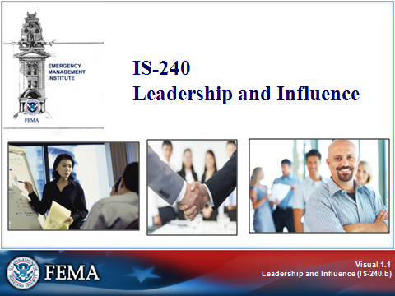
Key Points

Welcome to IS-240: Leadership and Influence. As an emergency management professional, you must be able to use leadership and influence effectively to lead your organization and the community in planning for, preventing, and responding to emergency situations and disasters.

Leadership involves providing vision, direction, coordination, and motivation toward achieving emergency management goals.
COURSE OVERVIEW
Visual 1.2

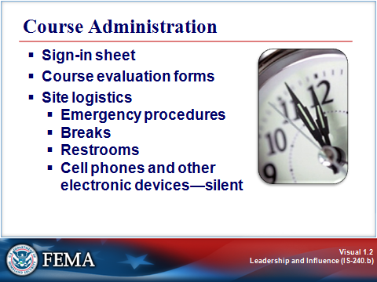
Key Points

- Sign-in sheet
- Course evaluation forms
- Site logistics
- Emergency procedures
- Breaks
- Restrooms
- Cell phones and other electronic devices—silent
COURSE OVERVIEW
Visual 1.3

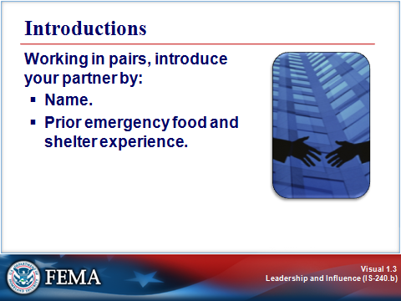
Key Points

COURSE OVERVIEW
Visual 1.4

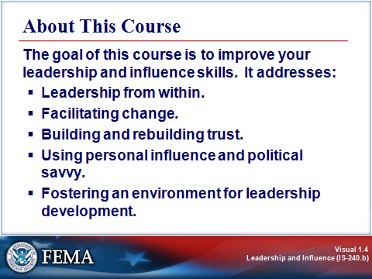
Key Points

Being able to lead others⎯to motivate them to commit their energies and expertise to achieving the shared mission and goals of the emergency management system⎯is a necessary and vital part of every emergency manager, planner, and responder’s job.

The goal of this course to improve your leadership and influence skills. The course addresses:

- Leadership from within.
- Facilitating change.
- Building and rebuilding trust.
- Using personal influence and political savvy.
- Fostering an environment for leadership development.

COURSE OVERVIEW
Visual 1.5

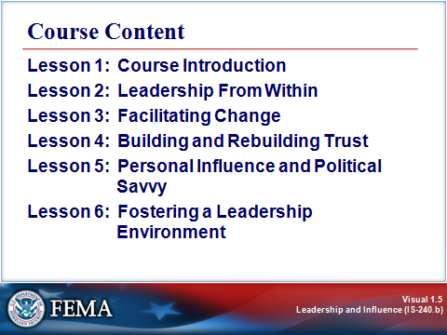
Key Points

This course is composed of six lessons.

- Lesson 1 offers an overview of the course content.

- Lesson 2 discusses what it means to be self-aware and the link between self-awareness and leadership.

- Lesson 3 explores the topic of change and how to facilitate change effectively in the emergency management environment.

- Lesson 4 focuses on the importance of building trust as a foundation for effective leadership and change management, and examines strategies for building and rebuilding trust.

- Lesson 5 addresses personal influence and political savvy and their role in each phase of emergency management.

- Lesson 6 examines the critical elements of a leadership environment and presents strategies for fostering such an environment.

LEADERSHIP IN EMERGENCY MANAGEMENT: WHAT’S AT STAKE?
Visual 1.6

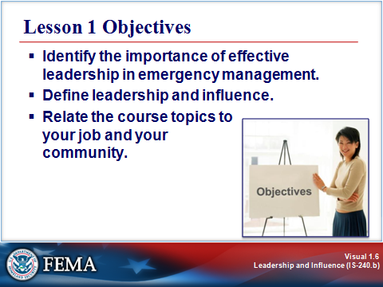
Key Points

As an emergency management professional, you must be able to use leadership and influence effectively to lead your organization and the community in planning for, preventing, and responding to emergency situations and disasters.

Leadership involves providing vision, direction, coordination, and motivation toward achieving emergency management goals. These skills are necessary whether dealing with subordinates, those with more authority than you, your peers in partner organizations, volunteers, or the public.

Upon completing this lesson, you should be able to:

- Identify the importance of effective leadership in emergency management.
- Define leadership and influence.
- Relate the course topics to your job and your community.

LEADERSHIP IN EMERGENCY MANAGEMENT: WHAT’S AT STAKE?
Visual 1.7

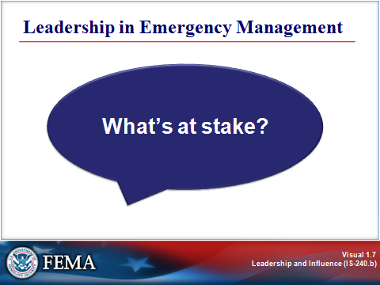
Key Points

Leadership is critically important when emergencies happen. By its very nature, emergency management connotes leadership⎯safeguarding life and property by marshalling both the will and the required resources to respond to and recover from an emergency quickly.

CASE STUDY: THE LOS CUCHILLOS FIRE
Visual 1.8

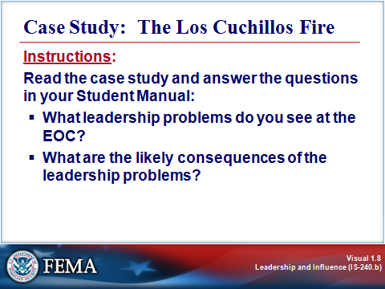
Key Points

To illustrate what can happen when emergency personnel cannot or do not exercise effective leadership, read the following case study and answer the questions.

What leadership problems do you see at the EOC?

What are the likely consequences of the leadership problems?

CASE STUDY: THE LOS CUCHILLOS FIRE
Visual 1.8 (Continued)

Case Study: The Los Cuchillos Fire

The Los Cuchillos fire began as a result of a private aircraft crash in the rugged Los Cuchillos Hills area. Local firefighters responded at 8:00 a.m. By noon, as the fire quickly grew to 20,000 acres, the Los Cuchillos Fire Department invoked its mutual aid agreements. This bolstered the firefighting force by two teams. Even with this support, the fire had spread to 40,000 acres by 6:00 p.m.

At 5:15 p.m., with all department and mutual aid fire assets committed, Fire Chief Ed Blakely called the County Emergency Operations Center (or EOC) and requested outside help. The County EOC contacted Ellen Burgess, the duty officer at the State EOC, and requested that the State Emergency Response Act be invoked. Under this act, the State Director of Emergency Management could commit State assets (such as people, equipment, and money) to the fire.

Ellen Burgess contacted Chief Blakely in the field. He told her that he could not hold the fire. It was headed straight for the Tres Rios Nuclear Power Plant and was also threatening the Los Cerros housing community. He told her that she needed to invoke the Emergency Response Act because he would definitely need State resources to fight the fire.

Acting State Director Rick Douglas considered the County’s request for State help. Rick was a cautious decisionmaker. He had encountered problems in the past when he had made decisions without getting all of the facts. Ellen Burgess told him, “The fire is out of control, mutual aid assets are committed, and the fire is headed for a nuclear power plant. There is really not much to think about.”

Rick and Ellen did not work well together. Each felt that the other was untrustworthy and, as a result, there was little cooperation or communication between them. Rick turned his back on Ellen and pondered the request.

The pace of State operations quickened. EOC staff members were busy fielding media calls, drafting situation reports, and trying to plot the location and size of the fire. Ellen confronted Rick and told him, “We need to move out on this thing. The fire is out of control and heading for the nuclear power plant. They are overwhelmed. We need to decide now.”

Rick backed away, and told her, “Stop! I am not going to make any kind of decision until I know how many fire rigs are on the scene.”

He then directed the Operations Section Chief to call the fire scene to find out how many fire assets were committed. This took several minutes and did not produce a satisfactory answer when Chief Blakely confessed that he was not exactly sure how many rigs were on the scene because the two mutual aid teams had not reported their strength.

At 6:50 p.m., the County Commissioner Vera Morgan called the EOC. She reported that they had just lost two homes in the Los Cerros community and wanted something done immediately. Rick replied that he was working on it and would get back to her. As he hung up, Ellen noted, “She is one upset lady. We have got to invoke the Emergency Response Act. Those people need help now!” Rick responded with frustration and told her he was still assessing the situation. He warned her not to push him.

CASE STUDY: THE LOS CUCHILLOS FIRE
Visual 1.8 (Continued)

Finally, at 7:20 p.m., after Operations learned that seven houses were destroyed and that the fire had spread to within a half mile of the nuclear power plant, Rick invoked the Emergency Response Act and released State firefighting assets.

By the time the fire was controlled, it had grown to 65,000 acres, destroyed seven homes and two businesses, and burned within 300 yards of the nuclear plant. The State response time would be an issue in the Los Cuchillos community.

LEADERSHIP AND INFLUENCE IN EMERGENCY MANAGEMENT
Visual 1.9

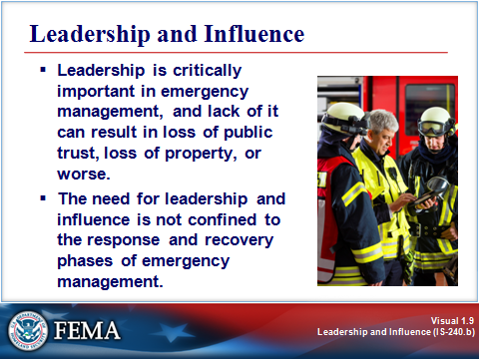
Key Points

As the case study illustrates, leadership is critically important in emergency management, and lack of it can result in loss of public trust, loss of property, or worse.

And the need for leadership and influence is not confined to the response and recovery phases of emergency management. Effective leadership is equally necessary for implementing mitigation programs and for emergency management preparedness and disaster prevention.

In all of these phases of emergency management, leadership and influence can take many forms. For example, you are leading and influencing when you:

- Invite other members of an emergency management team to a meeting to discuss common goals.
- Use that meeting as an opportunity to really listen, to learn “where they’re coming from” and what they’re aiming for.
- Ask for help with or input on a project that will help your community prepare for disasters.
- Speak out to persuade others to accept your point of view.
- Encourage someone else to assume the leadership role in a group.
- Work to establish partnerships with neighboring communities to share resources for prevention, preparedness, response, recovery, or mitigation.
- Recognize the differences among people and drawing on the strengths of your organization to prepare for emergencies.
- Marshal local resources to respond during an emergency.
- Demonstrate high standards of honesty, integrity, trust, openness, and respect for others.

These are only a few examples. You can probably think of many other leadership roles that you or those around you fulfill in the day-to-day operations of your job.

LEADERSHIP AND INFLUENCE IN EMERGENCY MANAGEMENT
Visual 1.10

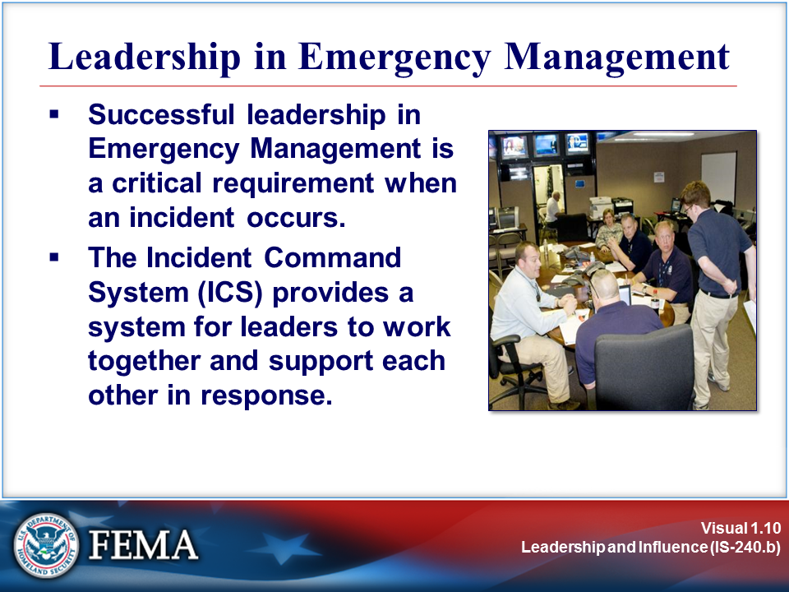
Key Points

Successful leadership in Emergency Management is a critical requirement when an incident occurs. The Incident Command System (ICS) provides a system for leaders to work together and support each other in response.

The Incident Command System is part of the National Incident Management System (NIMS) and plays an important part of ensuring unity of command during response operations.

The job aid on the next page provides additional information about the National Incident Management System (NIMS).

Job Aid: National Incident Management System (NIMS)

NIMS represents a core set of doctrines, concepts, principles, terminology, and organizational processes that enable effective, efficient, and collaborative incident management.
NIMS integrates smart practices into a comprehensive framework for use nationwide by emergency management/response personnel in an all-hazards context. These smart practices lay the groundwork for the components of NIMS and provide the mechanisms for the further development and refinement of supporting national standards, guidelines, protocols, systems, and technologies.
NIMS fosters the development of specialized technologies that facilitate emergency management and incident response activities, and allows for the adoption of new approaches that will enable continuous refinement of the system over time.

Key NIMS Components

- Preparedness: Effective emergency management and incident response activities begin with a host of preparedness activities conducted on an ongoing basis, in advance of any potential incident. Preparedness involves an integrated combination of assessment; planning; procedures and protocols; training and exercises; personnel qualifications, licensure, and certification; equipment certification; and evaluation and revision.
- Communications and Information Management: Emergency management and incident response activities rely on communications and information systems that provide a common operating picture to all command and coordination sites. NIMS describes the requirements necessary for a standardized framework for communications and emphasizes the need for a common operating picture. This component is based on the concepts of interoperability, reliability, scalability, and portability, as well as the resiliency and redundancy of communications and information systems.
- Resource Management: Resources (such as personnel, equipment, or supplies) are needed to support critical incident objectives. The flow of resources must be fluid and adaptable to the requirements of the incident. NIMS defines standardized mechanisms and establishes the resource management process to identify requirements, order and acquire, mobilize, track and report, recover and demobilize, reimburse, and inventory resources.
- Command and Management: The Command and Management component of NIMS is designed to enable effective and efficient incident management and coordination by providing a flexible, standardized incident management structure. The structure is based on three key organizational constructs: the Incident Command System, Multiagency Coordination Systems, and Public Information.
- Ongoing Management and Maintenance: Within the auspices of Ongoing Management and Maintenance, there are two components: the National Integration Center (NIC) and Supporting Technologies.

Additional information about NIMS can be accessed online at the FEMA Web site or by completing EMI’s IS-700 online course.

LEADERSHIP AND INFLUENCE IN EMERGENCY MANAGEMENT
Visual 1.11

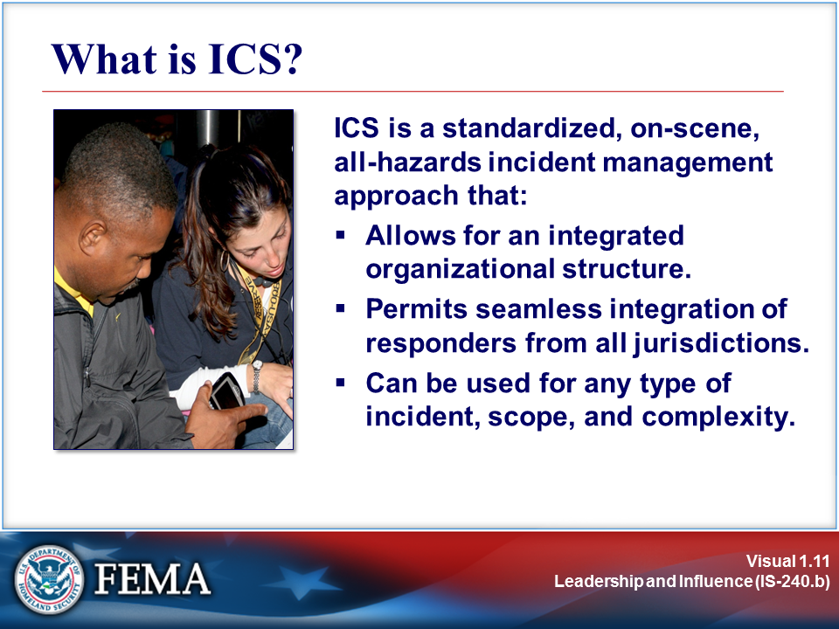
Key Points

ICS is a standardized, on-scene, all-hazards incident management approach that:

- Allows its users to adopt an integrated organizational structure that matches the complexities and demands of incidents.
- Permits seamless integration of responders from all jurisdictions.
- Can be used for incidents of any type, scope, and complexity.

NIMS promotes the use of ICS for every incident or scheduled event. Using ICS on all incidents helps hone and maintain skills needed for the large-scale incidents.

LEADERSHIP AND INFLUENCE IN EMERGENCY MANAGEMENT
Visual 1.12

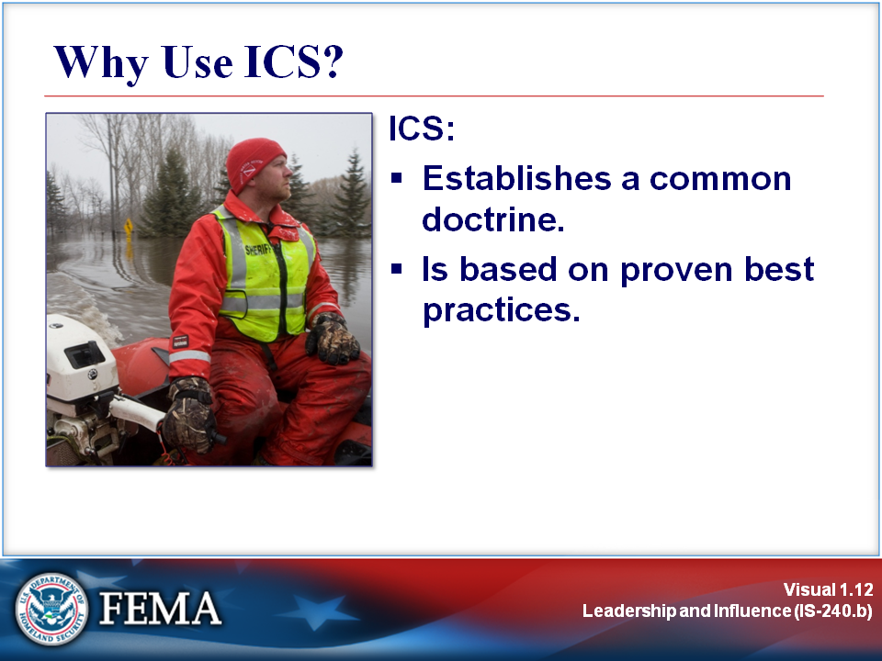
Key Points

ICS:
- Establishes a Common Doctrine. Having a common doctrine allows for emergency management personnel from many different jurisdictions to work together. NIMS and ICS provide a systematic, proactive approach guiding departments and agencies at all levels of government, the private sector, and nongovernmental organizations to work seamlessly to prepare for, prevent, respond to, recover from, and mitigate the effects of incidents, regardless of cause, size, location, or complexity, in order to reduce the loss of life and property, and harm to the environment.

- Is Based on Proven Best Practices. ICS works! It saves lives! Life safety is the top priority for ICS response.

By using management best practices, ICS helps to ensure:

- The safety of responders, workers, and others.
- The achievement of response objectives.
- The efficient use of resources.

LEADERSHIP AND INFLUENCE IN EMERGENCY MANAGEMENT
Visual 1.13

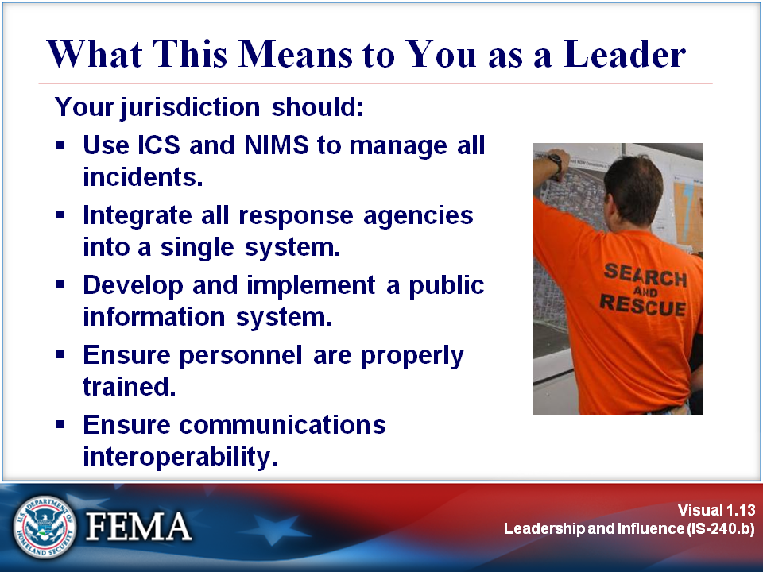
Key Points

Your jurisdiction should:

- Use ICS and NIMS to manage all incidents, including recurring and/or planned special events.
- Integrate all response agencies and entities into a single, seamless system, from the Incident Command Post, through departmental Emergency Operations Centers (EOCs) and local EOCs, through the State EOC, to the regional- and national-level entities.
- Develop and implement a public information system.
- Identify and type all resources according to established standards.
- Ensure that all personnel are trained properly for the job(s) they perform.
- Ensure communications interoperability and redundancy.

Remember the importance of working with Voluntary Organizations Active in Disaster (VOADs), NGOs, business and industry, and others to develop a plan for addressing volunteer needs before an emergency to help eliminate some of the potential problems that can occur during an emergency.

LEADERSHIP AND INFLUENCE: WHAT DO THEY MEAN?
Visual 1.14

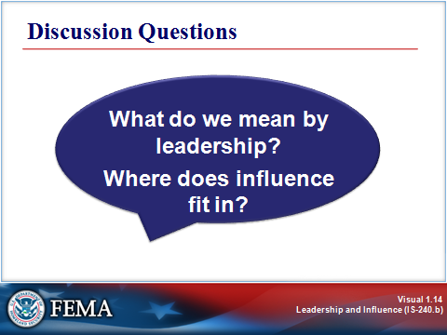
Key Points

So, exactly what do we mean by leadership? How does it differ (if at all) from management? And where does influence fit in?

Organizational development literature contains a wide range of definitions and descriptions of leadership. Some people argue that leadership and management are quite different and that they require different perspectives and skills. Others hold the view that leadership is a facet of management, and influencing is a facet of leadership.

In the context of this course, we’ll take the broad view:

A leader is someone who sets direction and influences people to follow that direction.

By this definition, a manager may or may not be a leader. This course is about developing the skills that are needed to become an effective leader.

LEADERSHIP AND INFLUENCE: WHAT DO THEY MEAN?
Visual 1.14 (Continued)

Leadership theories. There are numerous theories about leadership and about carrying out the role of the leader. Although this course will not delve into these theories in any depth, you may wish to seek more information on your own. Some of these theories include:

- Servant leader.
- Democratic leader.
- Principle-centered leader.
- Group-man theory.
- Great-man theory.
- Traits theory.
- Visionary leader.
- Total leader.
- Situational leader.

Leadership styles. Leaders carry out their roles in a wide variety of styles. Leadership style is influenced by the individual’s beliefs, values, and assumptions, as well as the organizational culture and the situation. Styles that have been identified include autocratic, laissez-faire, democratic, and others.

ACTIVITY: SELF-ASSESSMENT: LEADERSHIP BEHAVIORS
Visual 1.15

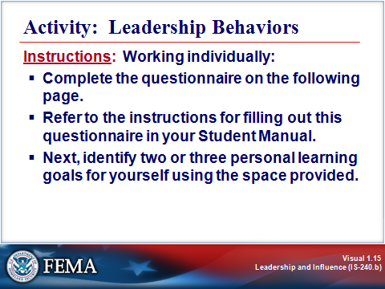
Key Points

Purpose: The purpose of this activity is to assess your leadership skills and priorities.

Time: 10 minutes

Instructions:

- Complete the self-assessment on the following page, as follows.

Imagine that you have a finite amount of time and skill with which to lead your department or work group (which, by the way, you do).

- In column one, assess your current proficiency in the 15 leadership behaviors by rating yourself on a scale of 1 to 10 for each behavior, with 1 representing No Proficiency, and 10 representing Full Proficiency.
- In column two, estimate how much time you spend on each of the 15 behaviors by apportioning your sum total (100%) of actual time spent among the behaviors.
- In column three, assess where you need to be spending your time for your work group to excel. Again, apportion your sum total (100%) of where you should be spending your time among each of the 15 behaviors.

Columns two and three must total 100%, but not every individual item may have a number in it. In other words, if you feel you have no skill in an area, or devote no time to it, you will leave that box blank.

ACTIVITY: SELF-ASSESSMENT: LEADERSHIP BEHAVIORS
Visual 1.15 (Continued)

Self-Assessment: Leadership Behaviors

Leadership Behaviors | How proficient are you in this behavior?  Rate from 1 to 10:  1 = No Proficiency  10 = Full Proficiency | How much time do you spend on this behavior?  Estimate the numeric percentage of your time spent on each. | For your group to excel, how should you apportion your time?  Express the numeric percentage of time you should spend on each.
Telescopic Behaviors
- Plan for the future.
- Remain up to date with emerging issues and trends.
- Communicate a sense of where the organization will be over the long term.
- Foster commitment.
- Emphasize organizational values.
- Challenge people with new goals and aspirations.
- Create a sense of excitement or urgency.
- Inspire people to take action.
Mid-Distance/Microscopic Behaviors
- Manage the efficiency of operations.
- Evaluate proposed projects.
- Integrate conflicting perspectives and needs.
- Manage performance.
- Focus on results.
- Solve problems.
- Influence operational decisions.
TOTALS | N/A | 100% | 100%

Adapted from Deep Change: Discovering the Leader Within, by Robert E. Quinn. San Francisco: Jossey-Bass: 1996 (p. 149).

ACTIVITY: PERSONAL LEARNING GOALS
Visual 1.16

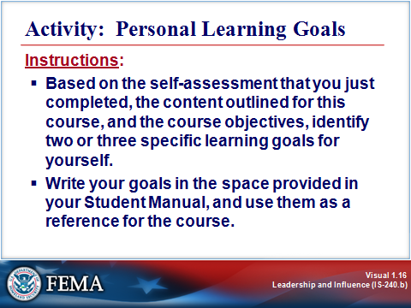
Key Points

Based on the self-assessment that you have just completed, the content outlined for this course, and the course objectives, identify two or three specific learning goals for yourself. Write your goals in the space below, and use them as a focus for the course.

Personal Learning Goals For This Course

SUMMARY AND TRANSITION
Visual 1.17

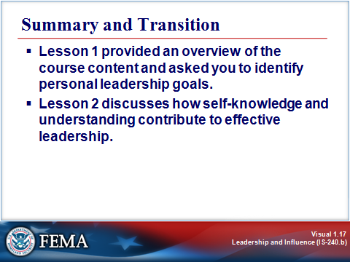
Key Points

Lesson 1 provided an overview of the course content and asked you to identify personal leadership goals. Lesson 2 discusses how self-knowledge and understanding contribute to effective leadership.

For More Information:

- FEMA EMI Independent Study Course IS-700: National Incident Management System (NIMS), An Introduction
- National Incident Management System (NIMS): http://www.fema.gov/emergency/nims/
- National Response Framework (NRF): http://www.fema.gov/emergency/nrf

